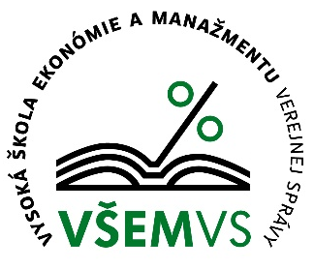 |  |  | 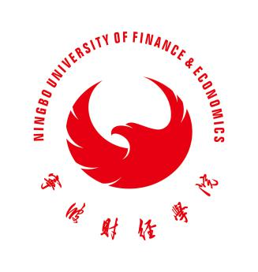
Official Announcement for a Teaching Opportunity at the School of Economics and Management in Public Administration in Bratislava, Slovakia
Deadline for applications: Dec.13, 2019

According to the Teaching Agreement between our university and School of Economics and Management in Public Administration in Bratislava, we intend to select one (1) outstanding teacher for this program. The duration of the program is from Feb. 2020 to May 2020, a total of 90 days. Under this program, the School of Economics and Management in Public Administration in Bratislava would provide an individual support of 980 Euro for the whole mobility and a one-time subsidy of 1500 Euro for the international air travel. All relevant colleges are invited to assist in the selection of such Teacher. An open and transparent selection process is required in order to ensure a fair, objective, and unbiased result.
Selection Criteria:

- Academic Background:0413 Management and Administration or Similar
- Good English language skills with B1 or CET 6 or an IELTS score of 5.5 or better (Excellent English Ability preferred)
- Interdisciplinary sciences ,Chinese History ,Chinese Language and Culture preferred
- Strong scientific research ability preferred

Selection Procedure:

- Interested and qualified teachers apply to their respective college
- Individual college selection commit recommends its preliminary list of candidates
- The Personnel Department and the Academic Affairs Office next audit these lists
- The International Cooperation Office organizes interviews to confirm and publicly announces the final list of candidates
- The International Cooperation Office submits this list to School of Economics and Management in Public Administration in Bratislava for its approval (the finalist are to be determined by the School of Economics and Management in Public Administration in Bratislava,)

Application materials:

- IELTS transcript or other relevant language proficiency certificates
- Letter of recommendation from the respective college

Contact Information:

Fifi Yang & Jenny Wang,International Cooperation Office, Rm 204/205, the Principal Administration Building
Tel：88052213, 88052270

International Cooperation Office
Ningbo University of Finance &Economics

