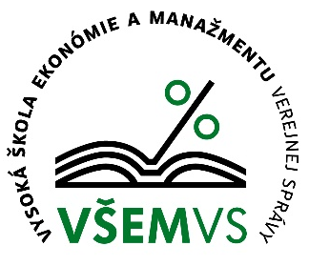 |  |  | 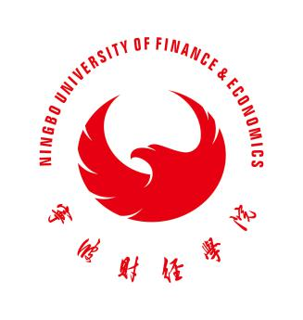
Official Announcement for a Traineeship & Study Opportunity at the School of Economics and Management in Public Administration in Bratislava, Slovakia
Deadline for applications: November 30th , 2019

According to the Erasmus Programme Agreement between our university and School of Economics and Management in Public Administration in Bratislava, we intend to select two (2) outstanding students for this program. The duration of the program is from Feb. 2020 to May 2020, a total of 90days (60days for traineeship programme and 90 days for study programme on the sideline). Under this program, students will be granted an individual support of 1600 Euro and a subsidy of 1500 Euro for the international air travel fare.At the meantime ,the students have to pay 1500 Euro for tuition and 800 Euro for accommodation to the School of Economics and Management in Public Administration in Bratislava. All relevant colleges are invited to assist in the selection of such students. An open and transparent selection process is required in order to ensure a fair, objective, and unbiased result.

Selection Criteria:

- Major of studies:0413 Management and Administration or similar
- Excellent academic performance with a GPA of 80% or better
- Law-abiding and possesses good morals, physical, and mental health
- Good English language skills with CET 6 or an IELTS score of 5.5 or better
- Void of any academic failure and disciplinary record
- Strong adaptability and economic affordability to live and study abroad

Selection Procedure:

- Interested and qualified students apply to their respective college
- Individual college selection commit recommends its preliminary list of candidates
- The Students Office and the Academic Affairs Office next audit these lists
- The International Cooperation Office organizes interviews to confirm and publicly announces the final list of candidates
- The International Cooperation Office submits this list to the the School of Economics and Management in Public Administration in Bratislava for its approval (the two finalists are to be determined by the School of Economics and Management in Public Administration in Bratislava)

Application materials:

- Transcript in both Chinese and English
- IELTS transcript or other relevant language proficiency certificates
- Letter of recommendations from the respective college

Fees:

During the traineeship and study programme in Slovakia, students are required to pay the regular fees at the NUFE.

Contact Information:

Fifi Yang & Jenny Wang,International Cooperation Office, Rm 204/205, the Administration Building
Tel：88052213, 88052270

International Cooperation Office
Ningbo University of Finance &Economics

